# 

# SOFTWARE ENGINEERING PROJECT

**Hospital Management System**

**Prepared by:**

Ark Upadhyay

Pratyush Kumar Sahoo

Sruti Mondal

Ayush Mitra

Pratyush Panda

# PROBLEM STATEMENT

In this busy world we don’t have the time to wait in infamously long hospital queues. The problem is, queuing at hospital is often managed manually by administrative staff, then take a token there and then wait for our turn then ask for the doctor and the most frustrating thing - we went there by traveling a long distance and then we come to know the doctor is on leave or the doctor can’t take appointments.

HMS will help us overcome all these problems because now patients can book their appointments at home, they can check whether the doctor they want to meet is available or not. Doctors can also confirm or decline appointments, this help both patient and the doctor because if the doctor declines’ appointment then patient will know this in advance and patient will visit hospital only when the doctor confirms’ the appointment this will save time and money of the patient.

Patients can also pay the doctor’s consultant fee online to save their time.

HMS is essential for all healthcare establishments, be it hospitals, nursing homes, health clinics, rehabilitation centers, dispensaries, or clinics. The main goal is to computerize all the details regarding the patient and the hospital. The installation of this healthcare software results in improvement in administrative functions and hence better patient care, which is the prime focus of any healthcare unit.

**Benefits of implementing a hospital management system:**

* **Appointment booking**

Helps patients cut the long queue and saves their time

Is equipped with features like automated email and text message reminders

* **Role-Based Access Control**

Allows employees to access only the necessary information to effectively perform their job duties

Increases data security and integrity

* **Overall cost reduction**

Cuts down paper costs as all the data are computerized

No separate costs for setting up physical servers

* **Data accuracy**

Removes human errors

Alerts when there’s a shortage of stock

* **Data security**

Helps to keep patients records private

Restricts access through role-based access control

* **Revenue management**

Makes daily auditing simple

Helps with statistics and other financial aspects

# SOFTWARE REQUIREMENT SPECIFICATION

1.1 Product Perspective

## 1.1.1 System Interfaces

## 1.1.2 System Specifications

### 1.1.2.1 H/W Requirement

### 1.1.2.2 S/W Requirement

1.1.3 Communication Interfaces

1.2 Product functions

1.3 Data Flow Diagram (DFD)

## 1.3.1 Context Level Diagram

1.4 Use Case Diagram

1.5 Use Case Description

1.6 User characteristics

1.7 Constraints

1.8 Assumptions and dependencies

1.9 Functional Requirements

1.10 Non-Functional Requirements

### 1.1 Product Perspective

This Hospital Patient Info Management System is a self-contained system that manages activities of the hospital.

Due to improperly managed details medical center faces quite a lot of difficulties in accessing past data as well as managing present data. The fully functional automated hospital management system which will be developed through this project will eliminate the disadvantages caused by the manual system by improving the reliability, efficiency and performance. The usage of a database to store patient, employee, stock details etc. will accommodate easy access, retrieval, and search and manipulation of data. The access limitations provided through access privilege levels will enhance the security of the system. The system will facilitate concurrent access and convenient management of activities of the medical center.

#### **1.1.1 System Interfaces**

* ***User Interfaces*** 
  + This section provides a detailed description of all inputs into and outputs from the system. It also gives a description of the hardware, software and communication interfaces and provides basic prototypes of the user interface.
  + The **protocol used** shall be **HTTP**.
  + The Port number used will be 80.
  + There shall be logical address of the system in IPv4 format.

* ***Hardware Interfaces*** 
  + **Laptop/Desktop PC**-Purpose of this is to give information when Patients ask information about doctors, medicine available lab tests etc. To perform such Action it need very efficient computer otherwise due to that reason patients have to wait for a long time to get what they ask for.
  + **Laser Printer (B/W)** - This device is for printing patients’ info etc.
  + **Wi-Fi router** - Wi-Fi router is used to for internetwork operations inside of a hospital and simply data transmission from pc’s to sever.

* ***Software Interfaces*** 
  + **JDK 1.8** - Java is fast, secure, and reliable. From laptops to data centers, game consoles to scientific supercomputers, cell phones to the Internet,
  + **Mysql server** - Database connectivity and management
  + **OS Windows 7/8/8.1**- Very user friendly and common OS
  + **JRE 1.8** - JAVA Runtime Environment for run Java Application and System

#### **1.1.2 System Specifications**

**1.1.2.1 H/W Requirement**

* Core i5 processor

☞ 2GB Ram.

* 20GB of hard disk space in terminal machines
* 1TB hard disk space in Server Machine

**1.1.2.2 S/W Requirement**

* Windows 7 or above operating system
* JRE 1.8
* Mysql server

#### **1.1.3 Communication Interfaces**

* **NIC (Network Interface Card)** – It is a computer hardware component that allows a computer to connect to a network. NICs may be used for both wired and wireless connections.
* **CAT 5 network cable**- for high signal integrity
* **TCP/IP protocol**- Internet service provider to access and share information over the Internet
* **Ethernet Communications Interface**- Ethernet is a frame-based computer network technology for local area networks (LANs)
* Ubiquitous, easy to set up and easy to use. Low cost and high data transmission rate.

### 1.2 Product functions

* Provide access to registered users only.
* Registration of new patients.

o Enable patient to view their record.

o Enable patient to update their record.

o Generate appointment date and timing.

* Confirmation by doctor.

o Patients can do Payment.

o Modification in schedule by patient.

o Admin access to patient’s record.

* Admin Verify Payment and Generate Bill/Receipt.
* Admin can view monthly/yearly records.

## 1.3 DATA FLOW DIAGRAM (DFD)

CONTEXT LEVEL DIAGRAM

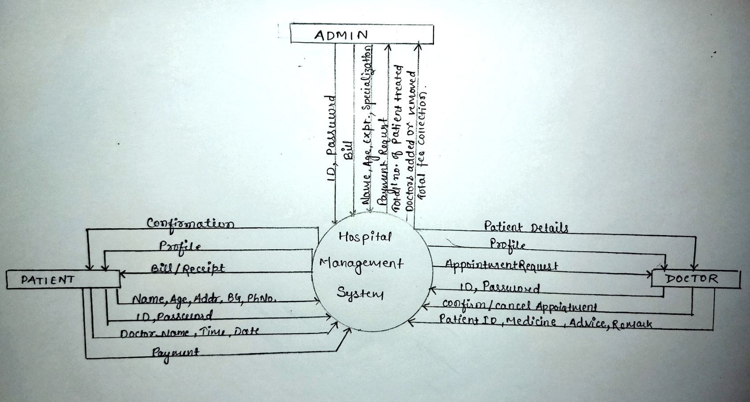

## 1.5 USE CASE DESCRIPTION

### (1) PATIENT

**\* REGISTRATION**

DESCRIPTION - The new patient can register themselves and add their details like name, age , gender, blood group etc. The patient entry will be made in the hms database.

PRE -CONDITION – The patient must be a new patient, If necessary fields left by user then prompt user to fill the necessary fields.

MAIN FLOW OF EVENTS

1. Patient selects sign up in login module. 2. A registration form get displayed

3. Patient fills the required details.

POST CONDITIONS - Patient record is added to hms database.

**\* UPDATION**

DESCRIPTION-The patient should be enabled to update his/her details and the changes should reflect in hms database.

PRE-CONDITION – The patient must be a registered patient, The patient cannot update details after treatment starts.

MAIN FLOW OF EVENTS

1. Patient logs in to the system.
2. Patient view his record
3. Patient selects update details.
4. Now patient may change the necessary fields.
5. Pop of update details.

POST CONDITION - The record of patient is updated in hms database.

**\*APPOINTMENT**

DESCRIPTION - It shows users a list of available doctors, timings, dates and enables patients to select the most suitable appointment date and doctor. The patient may also the cancel the appointment.

PRE-CONDITION - The patient must be a registered patient, Patient can fix only one appointment for a particular department.

MAIN FLOW OF EVENT

1. Patient first logs in to system.
2. View his/her record.
3. Create a new appointment or cancel the appointment..

POST CONDITIONS - patient details are displayed and a new appointment is fix or a existing appointment is cancelled. The hms database is updated.

\***PAYMENT**

DESCRIPTION – It enables user to pay the consultant fee of Doctor online.

PRE-CONDITION - The patient must be a registered patient, If Patient don’t wants to pay online he/she can pay by cash also.

MAIN FLOW OF EVENT

1. Patient first logs in to system.
2. View his/her record.
3. Appointment confirmed by the Doctor then go for Payment.

POST CONDITIONS – A Reciept will be displayed. The hms database is updated

### (2) DOCTOR

DESCRIPTION- The doctor view patient record/ update his details and add description of the treatment given to patient.

PRE-CONDITION – The doctor must be a registered doctor, System does not allow the doctor to modify the qualification, hospital managed details.

MAIN FLOW OF EVENTS

1.Doctor logs in to the system.

1. Doctor may select view patient.
   1. Patient record is displayed with treatment history.
2. Doctor add description of patient treatment.
3. Doctor may select appointment details
   1. Appointment Requests is displayed with schedule.
4. Doctor confirm or cancel appointment.

POST CONDITION – The patient and doctor ‘s database are updated.

### (3) ADMIN

DESCRIPTION - The admin add doctor, update docotr details and verify payment and generate Bill/Reciept for the same.

MAIN FLOW OF EVENTS

1. Admin logs in the system.
2. Admin may add doctor new doctor.
   1. admin fills the doctor’s details.
3. Admin view Doctor record.
   1. Admin enters the doctor id in the system.
   2. Doctor details are displayed, Admin can update details.
4. Admin Verify the payment submited by the Patient.
   1. Generate Bill/Reciept and confirmation message for the same.

PRE –CONDITION - Admin must first log in with his/her credentials.

POST CONDITION - The hms database is updated.

### 1.6 User characteristics

#### **ADMIN**

Admin has the full access to the system which means he is able to manage any activity with regard to the system. He is the highest privileged user who can access to the system.

***Key functions:***

•Access patient record, doctor Record.

•Add new doctor entry in system database.

* Confirm Payment and Generate Bill.
* View Records.(Total no of patients treated, doctor added/remove, consultant fee).

#### **PATIENT**

Patients can choose the best preferred appointments from the options provided and can also change the appointment schedule or cancel it. After appt. is confirmed by the respective doctor they can pay their consultant fee online. Patients have access to only their records.

***Key functions:***

* Make appointment.
* Cancel appointment.
* Update Details.
* Payment.
* View Payment History.

#### **DOCTOR**

Doctors can view the patient appointment list and provide the confirmation or make changes in the appointment list if required. Doctors have access to only records of those patients whom they are treating.

***Key functions***:

* Confirmation of appointment.
* Cancellation of appointment.
* Modification of appointment list.
* Add Prescription.

### 1.7 Constraints

* System is wirelessly networked with an encryption.
* System is only accessible within the hospital’s website only.
* Database is password protected.
* Should use less RAM and processing power.
* Each user should have individual ID and password.
* Only administrator can access the whole system.

### 1.8 Assumptions and dependencies

* Each user must have a valid user id and password
* Server must be running for the system to function

▪ Users must log in to the system to access any record.

* Only the Administrator can delete records.

## 1.9 FUNCTIONAL REQUIREMENTS

|  |  |  |  |
| --- | --- | --- | --- |
| **S.No.** | **MODULE NAME** | **APPLICABLE ROLES** | **DESCRIPTION** |
| 1. | LOGIN | PATIENT  DOCTOR  ADMIN | **PATIENT:** Can login using unique Id and Password after this system shall show his/her profile.    **DOCTOR:** Can login using unique Id and Password after this system shall show his/her profile.    **ADMIN:** Can login using unique Id and Password after this system shall show a profile with links to maintain the website. |
| 2. | REGISTRATION | PATIENT | **PATIENT:** Can Register by filling all the required details, after this the system will verify the details and check if already registered or not. |
| 3. | MAKE APPT. | PATIENT | **PATIENT:** Can Select doctor, date time and make an appointment request after this system shall show a confirmation for appointment request. |
| 4. | CANCL APPT. | PATIENT  DOCTOR | **PATIENT :** Can Cancel appointment if want to by just one click after this system shall ask for re-schedule or refund of payment.    **DOCTOR :** Can Cancel appointment if want to by just one click after this system shall send a message to the patient. |
| 5. | PAYMENT | PATIENT | **PATIENT :** Enter payment details and make payment after this system shall show the generated bill by the hospital. |
| 6. | DOCTOR MODULE | ADMIN | **ADMIN :** Can add a new doctor by filling all the details after this system shall show a confirmation message.  Can Remove a doctor by just one click after this system shall show confirmation message. |
| 7. | PATIENT MODULE | PATIENT | **PATIENT :** Can view payment history or can search for a particular bill also after this system shall show a bill or history.    Can also See or search for a doctor by entering dept. name or doctor id if known after this system will check for the doctor if found shall show doctor’s profile.    Can also update details after this system shall ask for re-enter password and after verifying password shall update details. |
| 8. | ADD  PRESCRIPTION | DOCTOR | **DOCTOR :** Enter Patient Id and after this all the treatment details and medicine, remark and advice for the patient after this system shall show a message for update. |

## 1.10 NON-FUNCTIONAL REQUIREMENTS

## 1.10.1 PERFORMANCE REQUIREMENTS

o **Response time**- The system will give responses within 1 second after checking the patient information and other information.

o **Capacity**-The system must support 1000 people at a time

o **User interface**- User interface screen will response within 5 seconds

## 1.10.2 SAFETY REQUIREMENTS

If there is extensive damage to a wide portion of the database due to catastrophic failure, such as a disk crash, the recovery method restores a past copy of the database that was backed up to archival storage and reconstructs a more current state by reapplying or redoing the operations of committed transactions from the backed up log, up to the time of failure. All the administrative and data entry operators have unique logins so system can understand who is login in to system right now no intruders allowed except system administrative nobody cannot change record and valuable data.

## 1.10.3 SECURITY REQUIREMENTS

1. Want take the responsibility of failures due to hardware malfunctioning.
2. Warranty period of maintaining the software would be one year.
3. Additional payments will be analyzed and charged for further maintenance.
4. If any error occur due to a user’s improper use. Warranty will not be allocated to it.
5. No money back returns for the software.

## 1.10.4 SOFTWARE SYSTEM ATTRIBUTES

**1.10.4.1 Usability:** Software can be used again and again without distortion.

**1.10.4.2 Availability:** The system shall be available all the time.

**1.10.4.3 Correctness:** Bug free software which fulfills the correct need/requirements of the client.

**1.10.4.4 Maintainability:** The ability to maintain, modify information and update fix problems of the system.

**1.10.4.5 Accessibility:** Administrator and many other users can access the system but the access level is controlled for each user according to their work scope.